CS 255 System Design Document Template

This template lays out all the different sections that you need to complete for Project Two. Each section has guidance to prompt your thinking. You will need to continually reference the interview transcript as you work to make sure that you are addressing your client’s needs. There is no required length for the final document. Instead the goal is to complete each section based on what your client’s needs are. Remove this note when you are finished, and replace all bracketed text with the relevant information.

UML Diagrams

UML Use Case Diagram
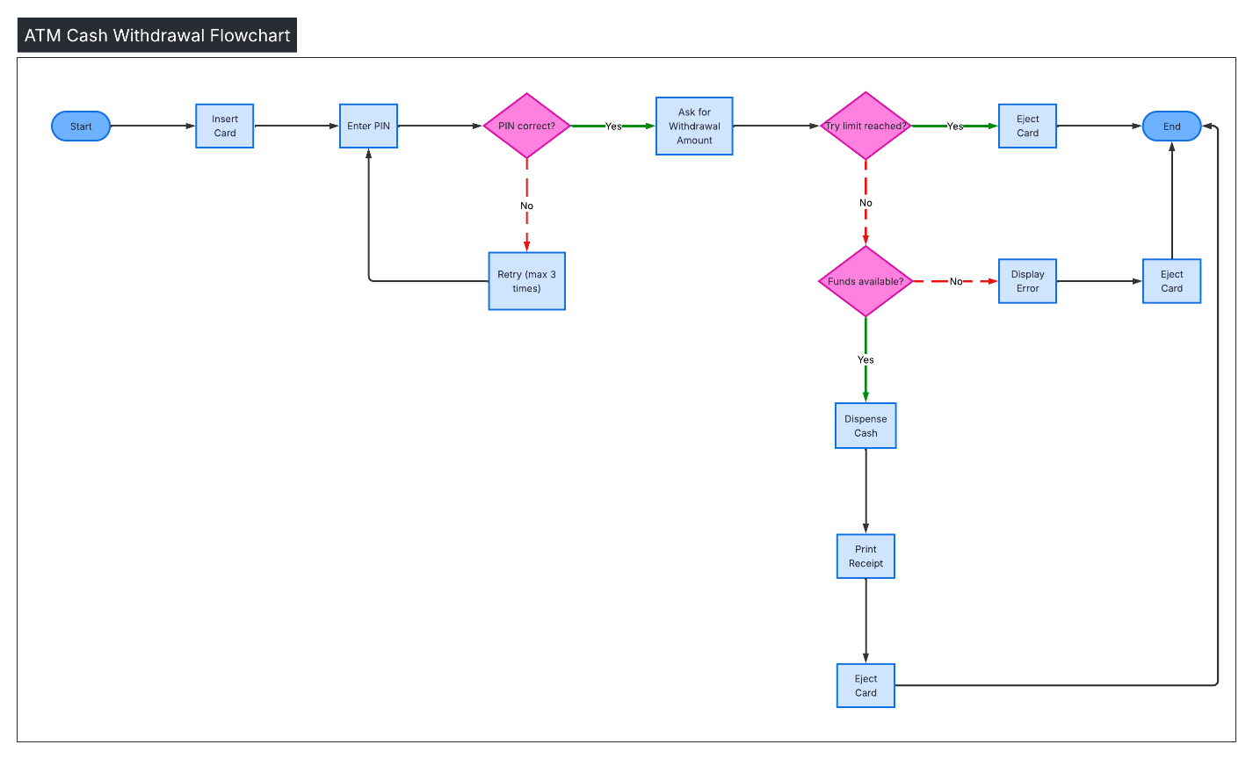

UML Activity Diagrams

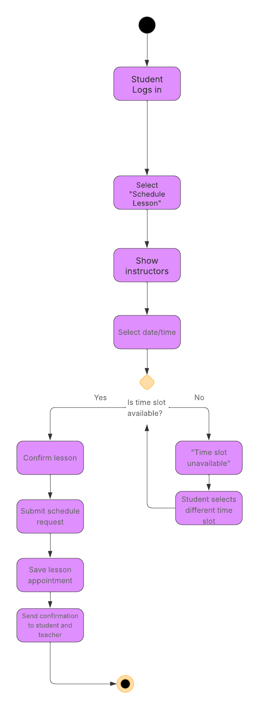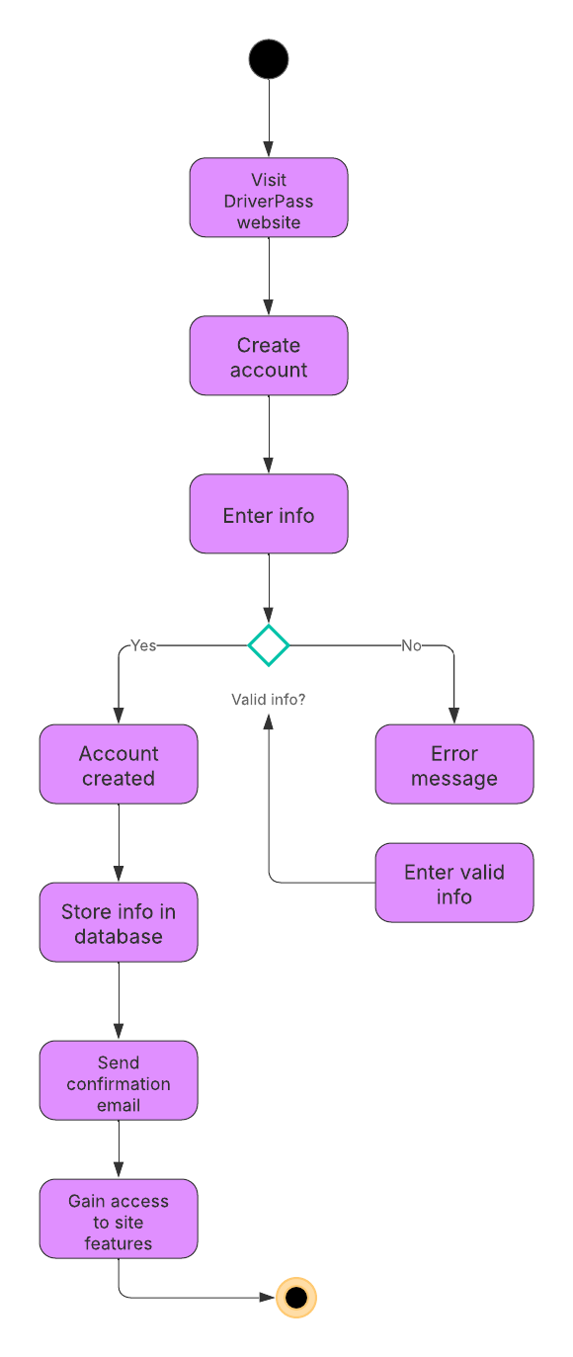

UML Sequence Diagram
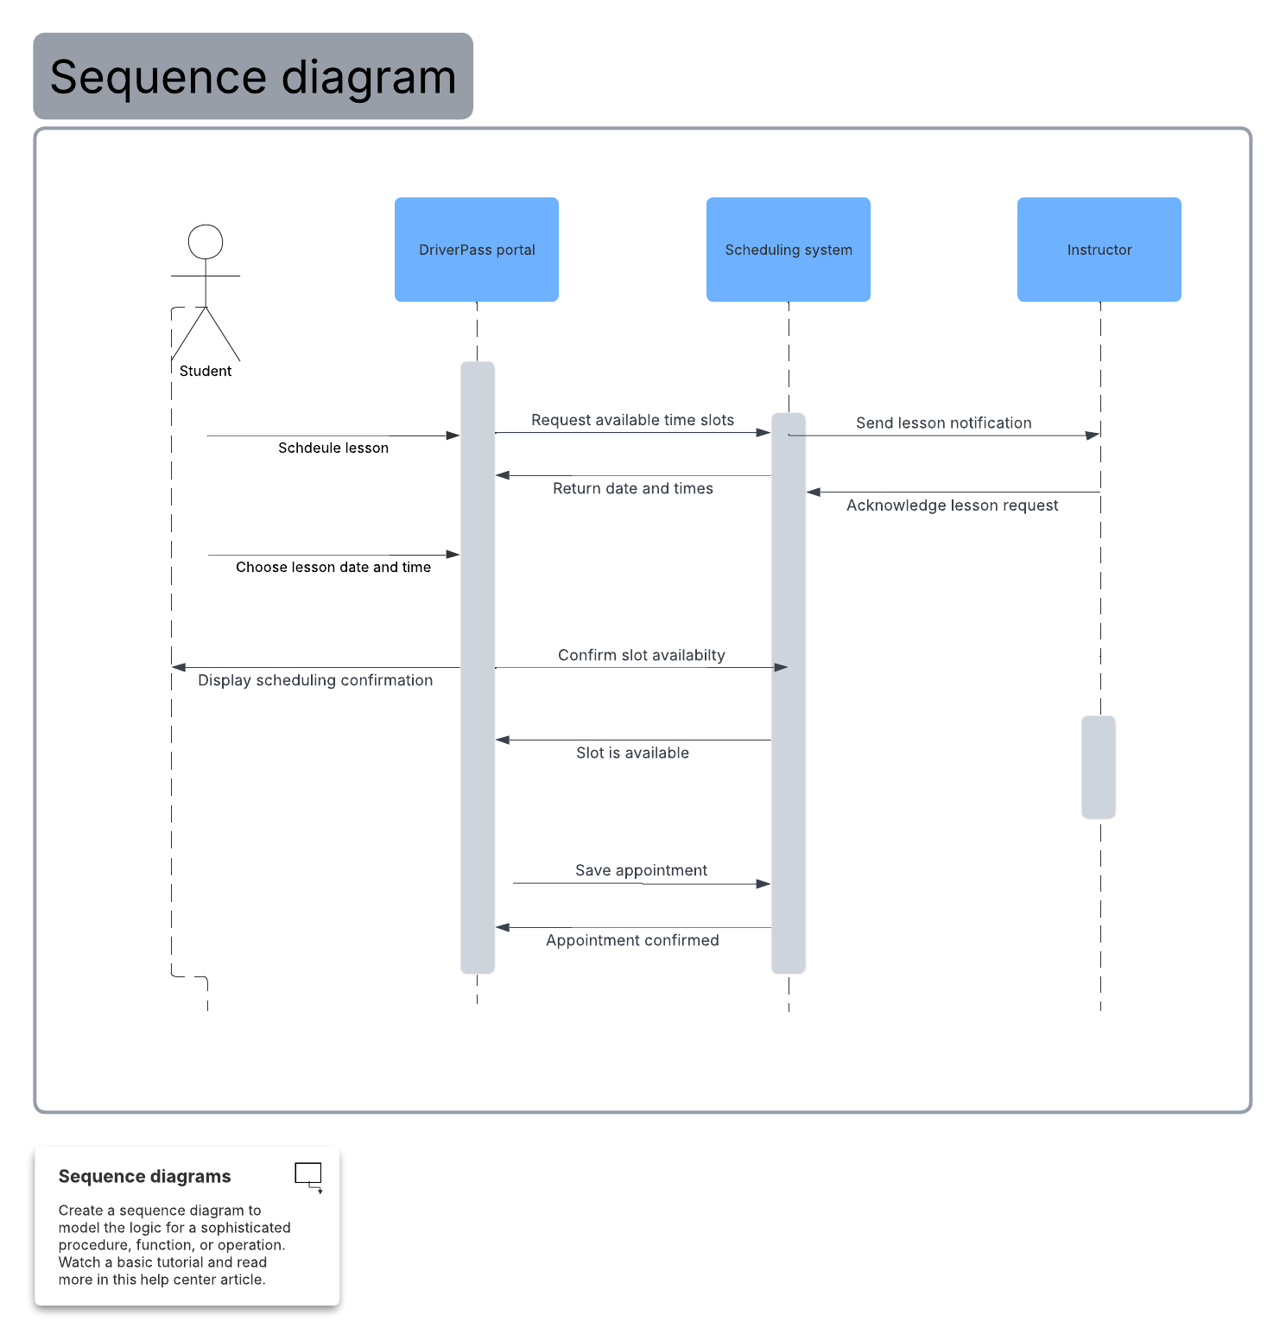

UML Class Diagram
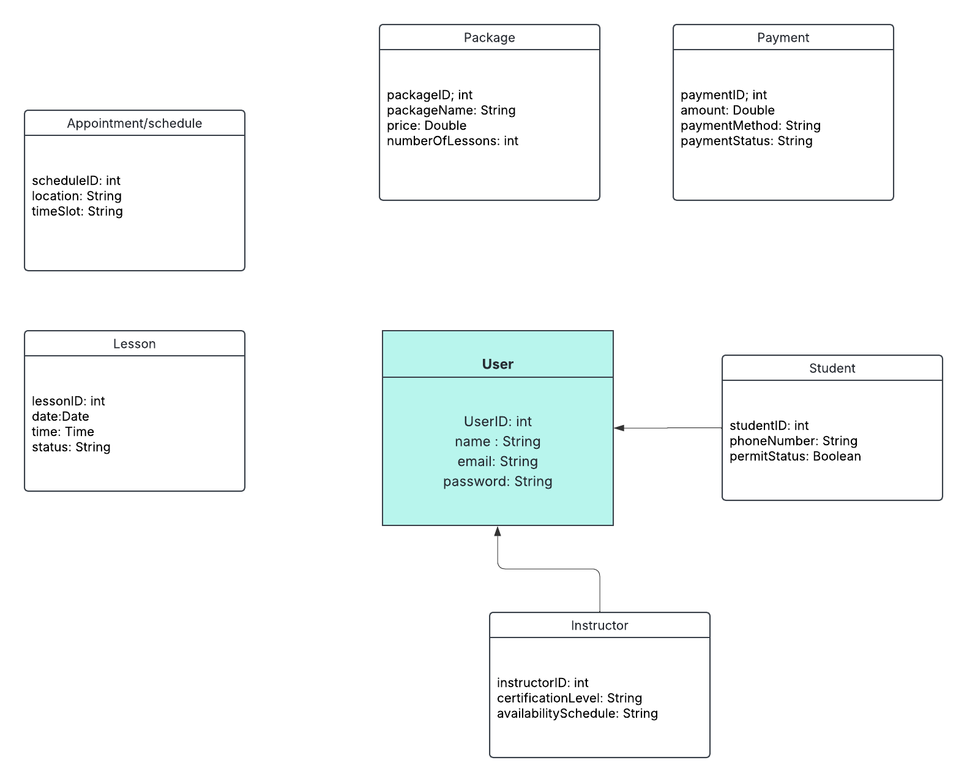

Technical Requirements
Based on the UML diagrams created, the DriverPass system will require a reliable combination of hardware, software, and infrastructure to support student registration, lesson scheduling, and payment processing. Because the system must be accessible to customers, instructors, and admins, it should be built as a secure online platform that can be used on both desktop and mobile devices.

From a hardware and infrastructure perspective, DriverPass will need a cloud based or dedicated server environment to host application and store scheduling, lesson, and customer account data. The system should also include a database server to manage user profiles, lesson appointments, instructor availability, and payment records. Staff members at DriverPass will require computers or tablets with internet access to manage schedules and assist customers, while instructors may also need mobile access for viewing upcoming lessons.

From a software and tools perspective, the system should include a web-based user interface for students to register accounts, purchase packages, and schedule lessons. Administrative users will need management features for updating lesson availability and monitoring appointments. The platform should integrate secure login authentication, payment processing support, and automated email or notification tools for confirming scheduled lessons. Overall, these technical requirements ensure the DriverPass system operates efficiently, securely, and meets the needs of both customers and business staff.

